EXP :1 SIMULATION OF FDMA USING MATLAB

Objective 1:
Aim : To simulate an FDMA system by allocating individual frequency channels to multiple users and determine the channel bandwidth assigned to each user.
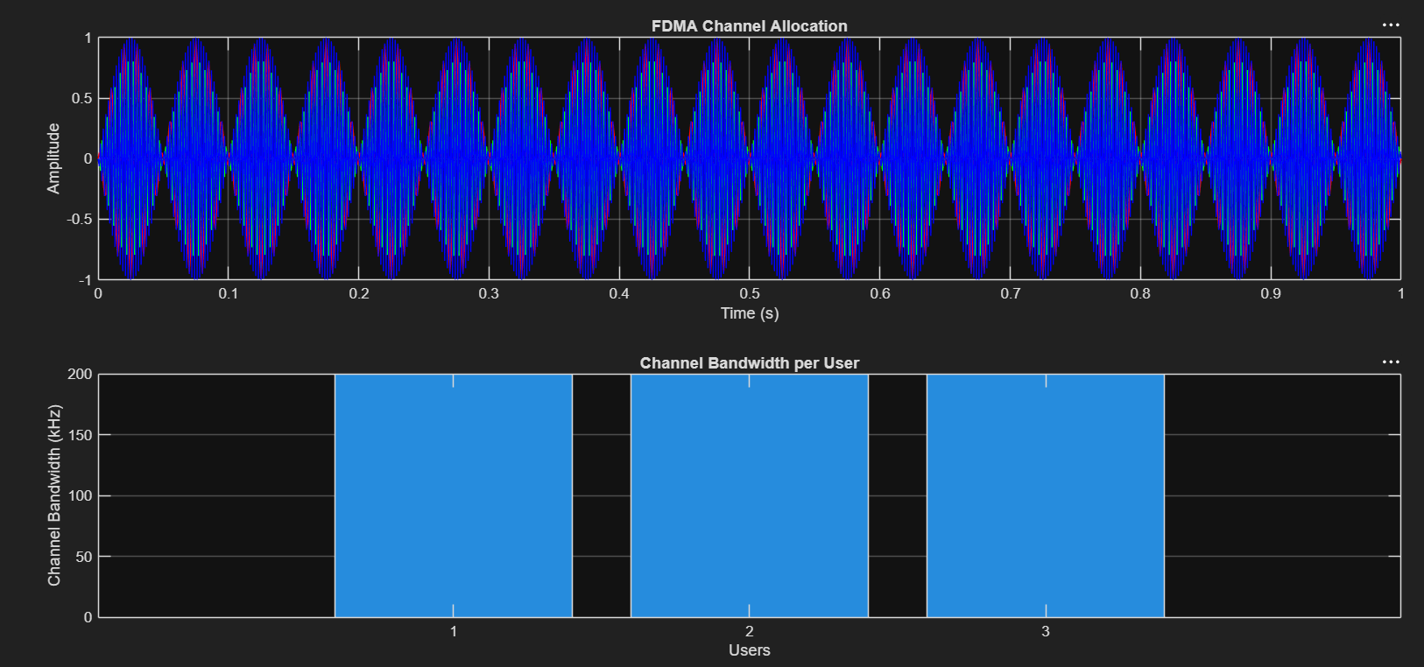
RESULT : 1. The FDMA system was successfully simulated by allocating separate frequency channels to three users, and the channel bandwidth assigned to each user was determined.

Objective 2:
AIM:
To calculate the data rate achieved by each user in the FDMA system based on the allocate channel bandwidth.
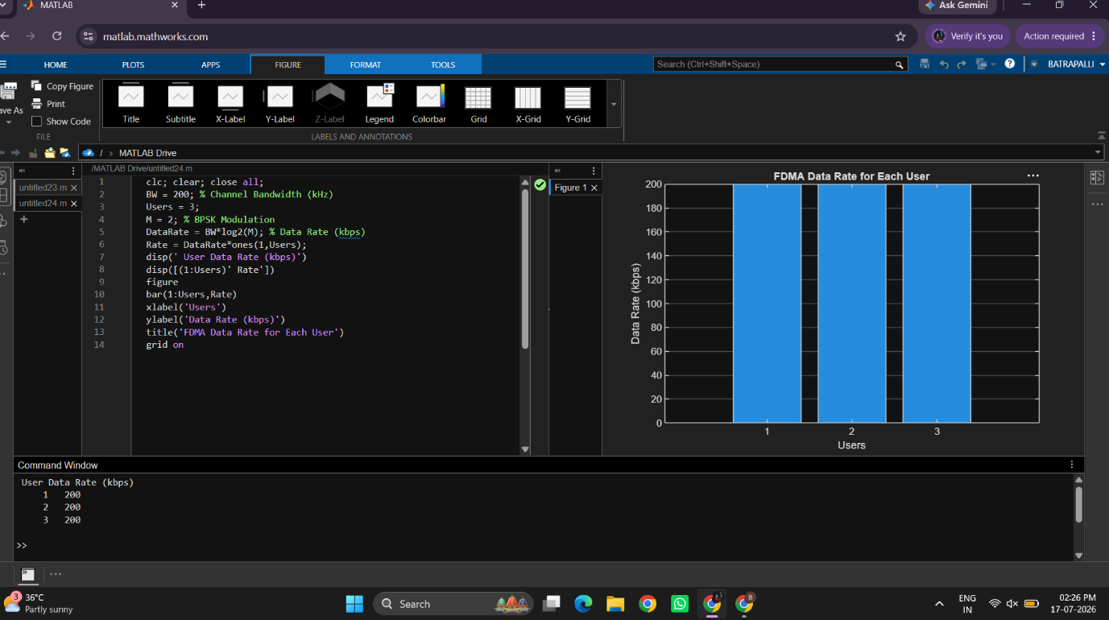
RESULT: To calculate the data rate achieved by each user based on the allocated channel bandwidth in the FDMA system.

Objective 3:
AIM: To evaluate the communication quality of the FDMA system by calculating the Signal-to-Noise Ratio (SNR) for different users.
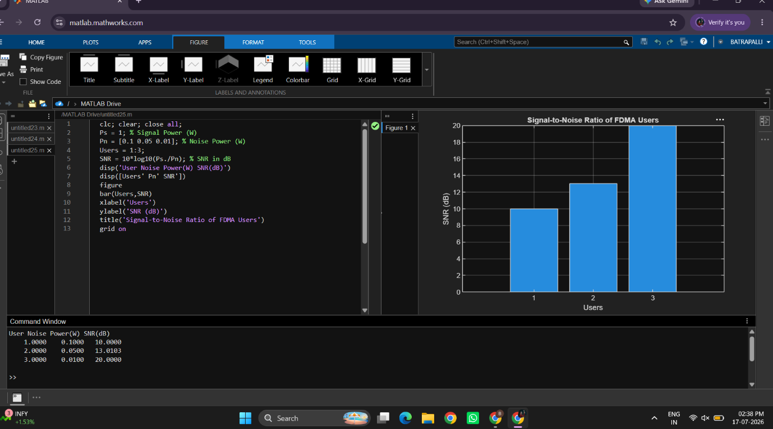
RESULT : To calculate the data rate achieved by each user based on the allocated channel bandwidth in the FDMA system.

